Collyer’s Site Map
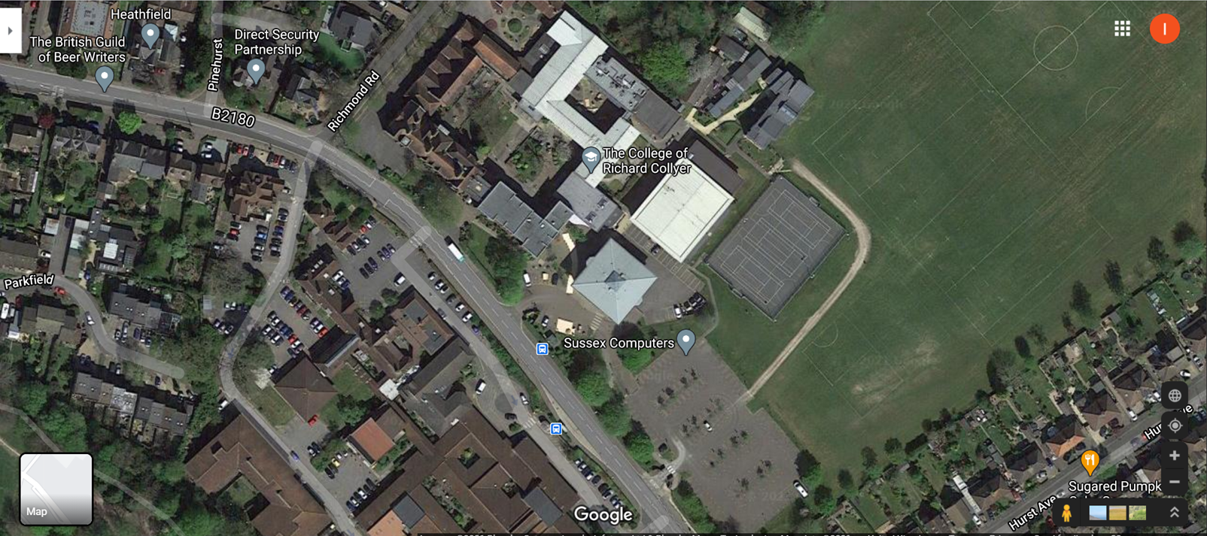
Right pointing arrow indicates entry gate
Left pointing arrow indicates exit gate
Triangle indicates main car park
Down pointing arrow indicates entry door to the sports hall
Circle indicates outdoor multicourt

